# Exercise: Text Processing

Problems for exercises and homework for the ["Programming Fundamentals" course @ SoftUni](https://softuni.bg/trainings/3448/programming-fundamentals-with-java-september-2021).

You can check your solutions in [Judge.](https://judge.softuni.bg/Contests/1670/Text-Processing-Exercise)

## Valid Usernames

Write a program that reads user names on a single line (joined by "**,** ") and prints all valid usernames.

A valid username is:

* Has **length** between 3 and 16 characters
* **Contains** only letters, numbers, hyphens and underscores

### 

|  |  |
| --- | --- |
| **Input** | **Output** |
| sh, too_long_username, !lleg@l ch@rs, jeffbutt | jeffbutt |
| Jeff, john45, ab, cd, peter-ivanov, @smith | Jeff  John45  peter-ivanov |

## Character Multiplier

Create a **method** that takes two strings as arguments and returns the sum of their character codes multiplied (multiply str1[0] with str2[0] and add to the total sum). Then continue with the next two characters. If one of the strings is longer than the other, add the remaining character codes to the total sum without multiplication.

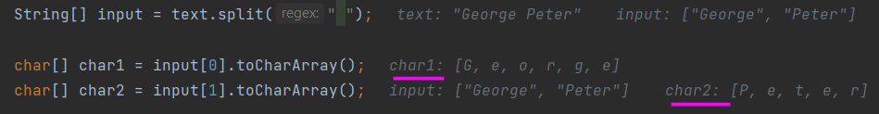

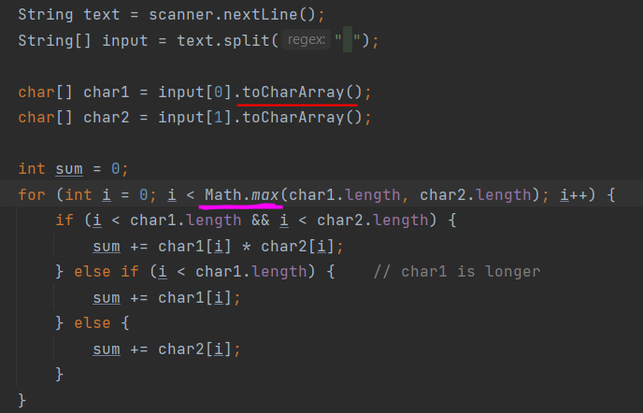 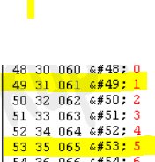

(49*53)2597+2500+2550= 7647

|  |  |
| --- | --- |
| **Input** | **Output** |
| George Peter | 52114 |
| 123 522 | 7647 |
| love SoftUni | 45337 |

## Extract File

Write a program that reads the path to a file and subtracts the file name and its extension.

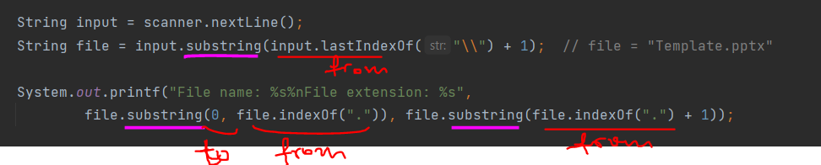

|  |  |
| --- | --- |
| **Input** | **Output** |
| C:\Internal\training-internal\Template.pptx | File name: Template  File extension: pptx |
| C:\Projects\Data-Structures\LinkedList.cs | File name: LinkedList  File extension: cs |

## Caesar Cipher

Write a program that returns an encrypted version of the same text. Encrypt the text by shifting each character with ***three positions forward***. For example A would be replaced by D, B would become E, and so on. Print the encrypted text.

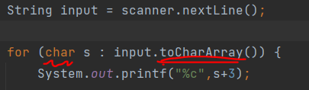 ***See also solution with adding chars to List***

### Examples

|  |  |
| --- | --- |
| **Input** | **Output** |
| Programming is cool! | Surjudpplqj#lv#frro$ |
| One year has 365 days. | Rqh#|hdu#kdv#698#gd|v1 |

## Multiply Big Number

You are given two lines – the first one can be a really big number (0 to 1050). The second one will be a single digit number (0 to 9). You must display the product of these numbers.

Note: do not use the BigInteger class.

|  |  |  |  |  |  |  |  |
| --- | --- | --- | --- | --- | --- | --- | --- |
| **Input** | **Output** |  | **Input** | **Output** |  | **Input** | **Output** |
| 23  2 | 46 | 9999  9 | 89991 | 923847238931983192462832102  4 | 3695388955727932769851328408 |

## Replace Repeating Chars

Write a program that reads a string from the console and replaces any sequence of the same letters with a single corresponding letter.

### 

|  |  |
| --- | --- |
| **Input** | **Output** |
| aaaaabbbbbcdddeeeedssaa | abcdedsa |
| qqqwerqwecccwd | qwerqwecwd |

## String Explosion // *similar to 6.*

Explosions are marked with ‘>’. Immediately after the mark, there will be an **integer**, which signifies the **strength** of the explosion.

You should **remove** x **characters** (where x is the **strength** of the explosion), **starting after** the punch **character** (‘**>**’).

If you find **another** explosion mark (‘>’) while you’re deleting characters, you should **add** the **strength** to your **previous** **explosion**.???

When all characters are processed, **print** the string **without** the **deleted** **characters**.

You should **not** delete the **explosion** character – ‘**>**’, but you should **delete** the **integers**, which represent the **strength**.

### Input

You will receive **single** **line** with the string.

### Output

Print what is left from the string after explosions.

### 

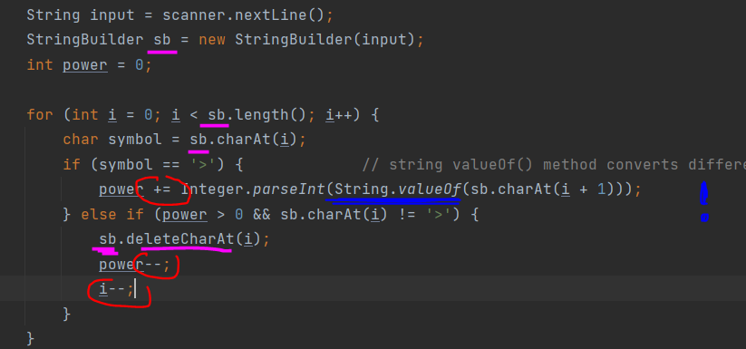



|  |  |  |
| --- | --- | --- |
| **Input** | **Output** | **Comments** |
| abv>1>1>2>2asdasd | abv>>>>dasd | 1st explosion is at index **3** and it is with **strength** of **1**. We delete **only** the **digit** **after** the explosion character. The string will look like this: abv>>1>2>2asdasd  2nd explosion is with strength **one** and the string transforms to this: abv>>>2>2asdasd  3rd explosion is now with strength of 2. We delete the digit and we find **another** explosion. At this point the string looks like this: abv>>>>2asdasd.  4th explosion is with strength **2**. We have **1** strength **left** from the previous explosion, we **add** the strength of the **current** explosion to what is **left** and that adds up to a **total** strength of **3**. We **delete** the next **three** **characters** and we **receive** the **string** abv>>>>dasd  We do **not** have **any more explosions** and we print the result: abv>>>>dasd |
| pesho>2sis>1a>2akarate>4hexmaster | pesho>is>a>karate>master |  |

## *Letters Change Numbers

Nakov likes Math. But he also likes the English alphabet a lot. He invented a game with numbers and letters from the **English** alphabet. The game was simple. You get a string consisting of a ***number between two letters***. Depending on whether the letter was in front of the number or after it you would perform different mathematical operations on the number to achieve the result.

**First** you start with the letter **before** the number.

* If it's **uppercase** you **divide** the number by the letter's **position** in the alphabet.
* If it's **lowercase** you **multiply** the number with the letter's **position** in the alphabet.

**Then** you move to the **letter after** the number.

* If it's **uppercase** you **subtract** its position from the resulted number.
* If it's **lowercase** you **add** its position to the resulted number.

But the game became too easy for Nakov really quick. He decided to complicate it a bit by doing the same but with **multiple** strings keeping track of only the **total sum** of all results. Once he started to solve this with more strings and bigger numbers it became quite hard to do it only in his mind. So he kindly asks you to write a program that **calculates the sum of all numbers after the operations on each number have been done**.

**For example**, you are given the sequence "A12b s17G":

We have two strings – **"**A12b**"** and **"**s17G**"**. We do the operations on each and sum them. We start with the letter before the number on the first string. **A is Uppercase** and its position in the alphabet is **1**. So we divide the number 12 with the position 1 (**12/1 = 12)**. Then we move to the letter after the number. **b is lowercase** and its position is 2. So we add 2 to the resulted number (**12+2=14)**. Similarly for the second string **s is lowercase** and its position is 19 so we multiply it with the number (**17*19 = 323)**. Then we have Uppercase G with position 7, so we subtract it from the resulted number (**323 – 7 = 316)**. Finally, we sum the 2 results and we get **14 + 316=330**.

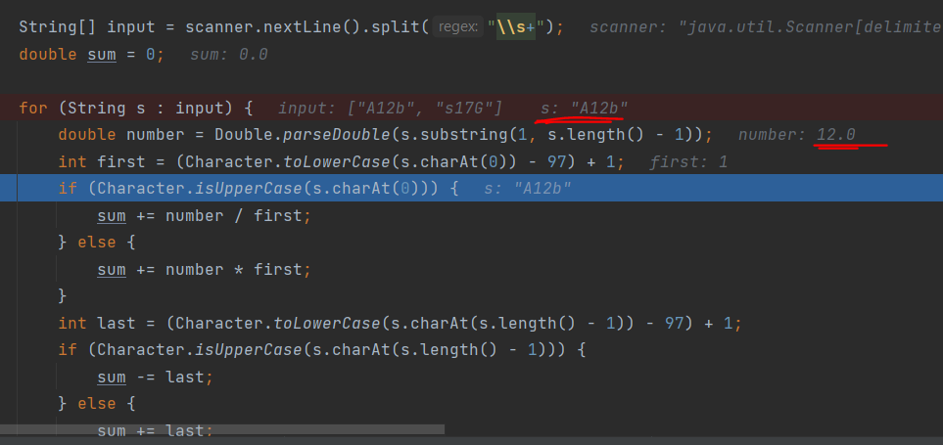

### Input

The input comes from the console as a **single line, holding the sequence of strings**. Strings are separated by **one or more white spaces**.

The input data will always be valid and in the format described. There is no need to check it explicitly.

### Output

Print at the console a single number: the **total sum of all processed numbers** rounded up to **two digits** after the decimal separator.

### Constraints

* The **count** of the strings will be in the range **[1 … 10].**
* The numbers between the letters will be integers in range **[1 … 2 147 483 647].**
* Time limit: 0.3 sec. Memory limit: **16** MB.

### Examples

|  |  |  |
| --- | --- | --- |
| **Input** | **Output** | **Comment** |
| A12b s17G | 330.00 | 12/1=12, 12+2=14, 17*19=323, 323–7=316, **14+316=330** |
| P34562Z q2576f H456z | 46015.13 |  |
| a1A | 0.00 |  |